Lesson10 - Lab: C Programming – Pointers
AIMS
To learn what pointers are, and how they are used.
Objectives
When you have completed this lesson, you should be able to:
- declare a pointer variable
- access pointer variables
- perform pointer arithmetic
- pass parameters to functions by reference
- explain the relationship between pointers and arrays

Procedure

Exercise 1 Introduction to Pointers
In this lab you will be introduced to pointers in C.
Copy the following program and comment every line, explaining its function and output. If any line produces an error, comment out that specific line and explain the nature of the error. Save your code for this part in a file called: lab10ex1.c
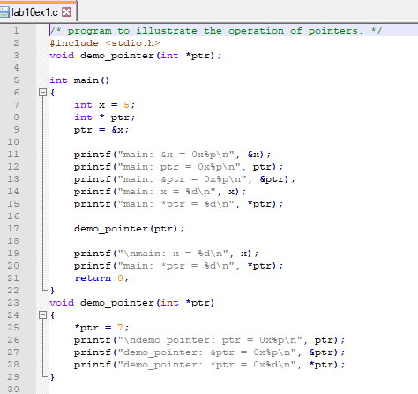

Compile, link and execute the program.
Fully Commented lab10ex1.c Code: Log your code and run attempt here >>
/* program to illustrate the operation of pointers */
#include <stdio.h>

void demo_pointer(int *ptr); // Function prototype

int main()
{
int x = 5; // Declare and initialize variable x
int *ptr; // Declare pointer variable ptr
ptr = &x; // Assign the address of x to ptr

printf("main: &x = 0x%p\n",&x); // Print the address of x
printf("main: ptr = 0x%p\n",ptr); // Print the value of ptr (address of x)
printf("main: &ptr =0x%p\n",&ptr); // Print the address of ptr
printf("main: x = %d\n",x); // Print the value of x
printf("main: *ptr=%d\n",*ptr); // Print the value at the address stored in ptr (value of x)

demo_pointer(ptr); // Call the demo_pointer function and pass ptr as an argument

printf("main: x = %d\n",x); // Print the value of x
printf("main: *ptr=%d\n",*ptr); // Print the value at the address stored in ptr (value of x)
}

void demo_pointer(int *ptr)
{
*ptr = 7; // Change the value at the address stored in ptr to 7
printf("\ndemo_pointer: ptr = 0x%p\n",ptr); // Print the value of ptr (address of x)
printf("demo_pointer: &ptr = 0x%p\n",&ptr); // Print the address of ptr
printf("demo_pointer: *ptr =0x%d\n",*ptr); // Print the value at the address stored in ptr (value of x)
}

Test Results >> (screen captures)
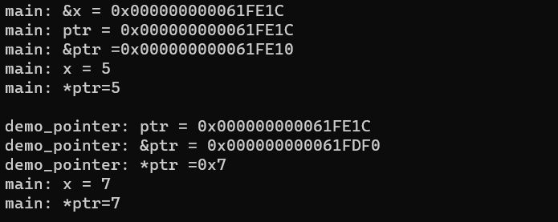

Comment on your Results – what were key learning points

Questions
- What does the & operator on line 8 mean?
- What does the format specifier %p display?
- Does the demo_pointers() function use pass by value or pass by reference?
- What is the difference between pass-by-reference and pass-by-value?

Answer
1. The & operator on line 8 is used to get the address of the variable x. It returns the memory address where the variable is stored.
2. The format specifier %p is used to display the value of a pointer variable in hexadecimal format.
3. The demo_pointers() function uses pass by reference. It takes a pointer as a parameter, allowing it to modify the value at the memory address pointed to by the pointer.
4. The difference between pass-by-reference and pass-by-value is how arguments are passed to a function. In pass-by-value, a copy of the argument is made and passed to the function. Any changes made to the argument within the function do not affect the original value. In pass-by-reference, the memory address of the argument is passed to the function. This allows the function to directly modify the original value.

Exercise 2 Arrays and Pointers
/* Code segment stores values into an array */
int i;
int x[10]; /* declare array x to contain 10 integers */

/* Assign values to the array x */
for(i=0; i < 10; i++)
{
x[i] = i + 1;
printf("x[%d] = %d\n", i, x[i]);
}

Create a new source file called lab10ex2.c. Take the code from above save as and modify it to use a pointer to reference the first element of the array instead of the array operator [], (except of course when declaring the array).

Compile, link and execute the program.
Code: Log your code and run attempt here >>
#include <stdio.h>

int main() {
int i;
int x[10]; // declare array x to contain 10 integers
int *ptr = x; // declare a pointer to reference the first element of the array

// Assign values to the array x using a loop and the pointer
for (i = 0; i < 10; i++) {
*(ptr + i) = i + 1;
printf("x[%d] = %d\n", i, *(ptr + i));
}

return 0;
}

Test Results >> (screen captures)

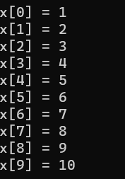

Comment on your Results – what were key learning points

Questions
- What happens if you increment a pointer?
- What do the following lines of code do?
int x[10];
int * ptr = x;
- Is there any advantage to using pointers over using the array operator []?

Answer
1. If you increment a pointer, it will point to the next memory location of the same data type. For example, if you have a pointer to an integer and you increment it, it will point to the next integer in memory.
2. The line "int x[10];" declares an array named x that can hold 10 integers.
The line "int *ptr = x;" declares a pointer named ptr and assigns it the address of the first element of the array x. This allows the pointer to reference the elements of the array.
3. Yes, there are advantages to using pointers over using the array operator [].
- Pointers allow for more flexibility in manipulating and accessing data. They can be used to dynamically allocate memory, create data structures, and pass data between functions.
- Pointers can be used to efficiently access and modify elements of an array, especially when dealing with large arrays or multidimensional arrays.
- Pointers can be used to implement more complex data structures and algorithms, such as linked lists and trees.
- Pointers can be used to optimize performance in certain situations, such as when working with large amounts of data or when performing low-level operations.

Exercise 3 Parameter Passing by Reference
Read lesson10 lecture notes page xx to xx.

Write, document, and test a program called lab10ex3.c that takes two integer pointers and exchanges the values of each. It returns void.

Example: given two integers 'a=2' and 'b=4', after the function swap(&a, &b) is called, 'a' will be 4 and 'b' will be 2

Compile, link and execute the program.
Code: Log your code and run attempt here >>
#include <stdio.h>
void swap(int *ptr1, int *ptr2) {
int temp = *ptr1;
*ptr1 = *ptr2;
*ptr2 = temp;
}

int main() {
int a = 2;
int b = 4;

printf("Before swap: a = %d, b = %d\n", a, b);

swap(&a, &b);

printf("After swap: a = %d, b = %d\n", a, b);

return 0;
}

Test Results >> (screen captures)

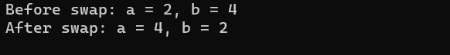

Comment on your Results – what were key learning points

